

REPUBLIQUE DU CAMEROON
PAIX-TRAVAIL-PATRIE
********************
MINISTERE DE L’ENSEIGNEMENT
SUPERUIEUR
*********************
Institute Supérieur La Perle


REPUBLIC OF CAMEROON
PEACE-WORK-FATHERLAND
********************
MINISTRY OF HIGHER EDUCATION
********************
The Pearl Higher Institute

ACADEMIC INTENDSHIP REPORT
DESIGN AND IMPLEMENTATION OF AN ONLINE EDUCATIONAL PLATFORM

The internship was carried out from the 25 June 2024 to the 30 August 2024 at SOCIETE DES SOLUTION TECHNOLOGIQUES (SST) in partial fulfilment of the requirement for the award of the Higher National Diploma (HND).
Field of study: COMPUTER ENGINEERING
Option: SOFTWARE ENGINEERING
Written and presented by:
KEPLO LONGANG KESSY ELOISHA
Registration Number: 25SWE0216

PROFESSIONAL SUPERVISOR
M. NDEMGO GAETAN
ADMINISTRATOR OF SST
ACADEMIC SUPERVISOR
M. NDOROH
LECTURER AT THE CENULAPE
ACADEMIC YEAR 2024 / 2025

DECLARATION

I, KEPLOLONGANG KESSY hereby declare that I am the author of the project entitled DESIGN AND IMPLEMENTATION OF AN ONLINE EDUCATIONAL PLATFORM
. I then authorize the school, ISLAPE to lend this thesis to other institutions or individuals who may want to carry out academic research. I am aware of the University’s policy on this.

CERTIFICATION

This is to certify that this report titled DESIGN AND IMPLEMENTATION OF AN ONLINE EDUCATIONAL PLATFORM has been carried out by KEPLO LONGAN KESSY ELOISHA with ISLAPE registration number: 25SWE0216 in partial fulfilment of the requirements for the award of a Higher National Diploma in Software
PROFESSIONAL SUPERVISOR
M. NDEMGHO GAETAN
ADMINISTRATOR OF SST

SIGNATURE………………………............
DATE……………………………………….

ACADEMIC SUPERVISOR
M. NDOROH OSWALD
LECTURER AT THE CENULAPE

SIGNATURE………………………………
DATE……………………………………….

UNDER THE SUPERVISION OF:

DEDICATION

TO MY FAMILY

ACKNOWLEDGEMENTS

I wish to intend my gratitude to those wonderful minds who gave their inevitable moral, material and financial assistance to realize this work.

Thanks to the great promoter of THE PEARL HIGHER INSTITUTE Mme. NOAH JUSTINE LEOCADIE épouse NDZANA for the creation of this institution in a conductive and bilingual environment for us.

My gratitude to the DAAC, DR OHANDJA PAUL FRANCIS for the proper management he handles in the pearl higher institute.

Special thanks to my academic supervisor Mr. NDOROH for his assistance, advice and guidelines for the accomplishment of this report.

Thanks to all my lecturers especially from the SOFTWARE ENGINEERING department

Thanks to SST for haven given me the opportunity to carry out my internship in their training center. My professional supervisor M. NDEMGO GAETAN

Great Thanks to my parents M. J. LONGANG CHRISPAIN and MRS FEMEGNI LONGANG ENGELINE for their support and advices

Profound gratitude to my brothers MR TAMBOU KEVIN AND PANGWA STEPHANE for their support and advices which helped me in my academic improvement and project development

Thanks to ANOUMANG FILS KEVIN for his support throughout the development of this project
Thanks to my friends from each department and the rest of the class.

PREFACE

The PEARL HIGHER INSTITUT (ISLAPE) is a private higher education created in 2017 which offers a training in the commercial, industrial and medical skills to its students in the BTS cycle, HND, LICENCES and PROFESSIONAL MASTERS. It comprises of two campus with the main campus at Yassa (situated 50 m from carrefour Yassa on the road going towards Leprosy) and the annex campus is at AKWA beside Collège Libermann (Derrière le Bureau CIM des impôts Entrée Foyer Marin).

CYCLE BTS
- Filières de commerce, droit, gestion et Tourisme
- Droit
- Assistanat Judiciaire
- Droit foncier et domanial
- Douane –Transit
- Gestion Fiscale
- Commerce
- Assurances
- Communication des organisations
- Commerce international
- Marketing Commerce Vente
- Gestion
- Banque et finance
- Comptabilité et gestion des entreprises
- Gestion des ressources humaines
- Gestion Logistique et transport
- Gestion des projets
- Gestion des systèmes d’information
- Statistiques
- Tourisme
- Génie Culinaire
- Gestion et Management Hôtelier
- Filières industrielles
- Génie civil
- Bâtiment
- Géotechnique et géologie appliquée
- Travaux Publics
- Géomètre – Topographe
- Génie électrique, énergétique et mécanique
- Electrotechnique
- Electronique
- Energies renouvelables
- Froid et climatisation
- Maintenance des appareils biomédicaux
- Technologies de la marine marchande
- Génie informatique
- Génie logiciel
- E-Commerce
- Informatique industrielle et automatisme
- Infographie Web Design
- Maintenance des systèmes informatiques
- Réseaux et Télécommunication
- Réseaux et sécurité
- Télécommunications
- Filières de santé
Il s’agit de l’innovation majeure de la prochaine rentrée académique 2021/2022. Les BTS Santé seront constitués des spécialités suivantes :
- Sage-femme
- Sciences infirmières
- Opticien-lunetier
- Techniques de laboratoire et d’analyse médicale
- Techniques pharmaceutiques
Le Cycle BTS Santé s’inscrit en complément de l’offre de l’Ecole de Formation des Personnels de Santé « LA PERLE » (ECOSAPE) qui, sous la Tutelle du Ministère de la Santé (Décision No 1711/D/MINSANTE/SG/DRH/SDDRH du 05 août 2020) et sur concours forme en :
- IDE (Infirmiers Diplômés D’Etat)
- TMS (Techniciens Médicaux Sanitaires)
- ATMS (Agents Techniques Médicaux sanitaires)
- ASG (Aide Soignants Généralistes)

CYCLE HND
- COMMERCIALS
- Accountancy
- Human Resource Management
- Logistic and Transport Management
- Banking and Finance
- Marketing
- Insurance
- Secretarial studies
- Public service and administration
- INDUSTRIALS
- Computer Engineering
- Topography
- SWE (Software Engineering)
- Civil Engineering
- Mechanical Engineering
- Electrical and Electronic Engineering

CYCLES LICENCES ET MASTERS PROFESSIONNELS
Les cycles Licences et Masters professionnels sont fonctionnels depuis la rentrée académique 2020/2021 sous la Tutelle académique de l’Université et précisément les tutelles techniques des Ecoles et Facultés suivantes :
- Ecole Nationale Supérieure Polytechnique de Douala (ENSPD)
- Ecole Supérieure des Sciences Economiques et de Commerce (ESSEC)
- Faculté des Sciences Juridiques et Politiques (FSJP)
- Faculté des Sciences Economiques et de Gestion Appliquée (FSEGA)
Les formations sont les suivantes :
- LICENCES PROFESSIONNELLES
- Commerce – Gestion – Carrières Juridiques – Tourisme

- Logistique et transport
- Publicité
- Communication Marketing
- Communication des organisations
- Marketing Commerce Vente
- Management des opérations du commerce international
- Sciences et techniques de l’administration
- Gestion de la qualité
- Marketing Manager opérationnel
- Comptabilité – Contrôle – Audit
- Finance et comptabilité
- Gestion des ressources humaines
- Banque Conseil et gestion de la clientèle
- Banque – Assurance
- Douane-transit
- Conseil juridique et fiscal
- Administration des collectivités territoriales décentralisées
- Droit immobilier et gestion du patrimoine
- Création et management des entreprises touristiques et hôtelières
- Industrie
- Génie civil
- Génie mécanique et productique
- Hygiène sécurité et sureté industrielle
- Electromécanique
- Robotique industrielle
- Génie minier
- Génie industriel et maintenance
- Génie logiciel
- Management des systèmes d’information
- Sécurité des systèmes d’information
- Réseaux et télécommunication
- Technologie automobile
- Valorisation des énergies renouvelables
- Génie thermique
- MASTERS PROFESSIONNELS
- Commerce – Gestion – Carrières Juridiques – Tourisme
- Conseil juridique et fiscal
- Juriste Conseil d’entreprise
- Transports internationaux et logistique
- Administration et gouvernance publiques locales
- Création et management des entreprises touristiques et hôtelières
- Banque et Finance
- Gestion des ressources humaines
- Marketing et communication
- Fiscalité
- Audit comptable et financier
- Management logistique et stratégie
- Industrie
- Génie civil
- Génie énergétique et environnement
- Génie électrique et informatique industrielle
- Administration et sécurité des réseaux

ABSTRACT

During our two-month internship at SST, a company specialized in the sale and provision of IT services, we had the opportunity to explore various experiences in the professional world and showcase the skills and knowledge we have acquired as second-year software engineering students at ISLAPE. This internship report focuses on the automation of one of SST's main activities, namely the sale of IT products. Managing products in the context of e-commerce is of great importance for a commercial company. With this in mind, we decided to design an application that automates this process. The approach used to develop this report is divided into two phases. Firstly, we will conduct an environmental study by presenting the SST company, as well as a thorough analysis of the current sales management system. Then, we will proceed with the modeling of the future system by developing a professional website for an enterprise called GAS SECURITY. This approach allowed us to gain a detailed understanding of the sales management process used at SST. We then carried out a modeling system, taking into account the specific needs of the company, in order to propose a solution that can be successfully implemented. This internship has been a rewarding experience that allowed us to apply our skills in software design and programming. We also had the opportunity to work as a team and develop our skills to meet the requirements of a company specialized in IT services. This internship report details the activities we have carried out, the results obtained, and the challenges we have faced. It highlights the importance of designing a professional website for a company like GAS under SST supervision. We are grateful to SST for offering us this internship opportunity and we are confident that the knowledge and skills we have gained during this period will be valuable for our academic path and future career in software engineering.

KEYWORDS
Internship, two months, SST (company specialized in the sale and provision of IT services), Professional world experiences
Skills and knowledge
Software engineering student
Automation
Sale of IT products
Product management
Website creation for an enterprise

RESUME

Pendant notre stage de deux mois chez SST, une entreprise spécialisée dans la vente et la fourniture de services informatiques, nous avons eu l'occasion de découvrir diverses expériences dans le monde professionnel et de mettre en pratique les compétences et connaissances acquises en tant qu'étudiants en deuxième année de génie logiciel à l'ISLAPE. Ce rapport de stage se concentre sur l'automatisation de l'une des principales activités de SST, à savoir la vente de produits informatiques. La gestion des produits dans le cadre du commerce électronique est d'une grande importance pour une entreprise commerciale. C'est dans cette optique que nous avons décidé de concevoir une application qui automatise ce processus. L'approche adoptée pour l'élaboration de ce rapport se divise en deux phases. Dans un premier temps, nous réaliserons une étude de l'environnement en présentant l'entreprise SST ainsi qu'une analyse approfondie du système actuel de gestion des ventes. Ensuite, nous procéderons à la modélisation du futur système en développant un site web professionnel pour une entreprise appelée GAS SECURITY. Cette démarche nous a permis d'acquérir une compréhension détaillée du processus de gestion des ventes utilisé chez SST. Nous avons ensuite effectué une modélisation du système, en tenant compte des besoins spécifiques de l'entreprise, afin de proposer une solution pouvant être mise en œuvre avec succès. Ce stage a été une expérience enrichissante qui nous a permis d'appliquer nos compétences en conception logicielle et en programmation. Nous avons également eu l'opportunité de travailler en équipe et de développer nos compétences pour répondre aux exigences d'une entreprise spécialisée dans les services informatiques. Ce rapport de stage détaille les activités que nous avons menées, les résultats obtenus et les défis auxquels nous avons été confrontés. Il met en évidence l'importance de concevoir un site web professionnel pour une entreprise comme GAS sous la supervision de SST. Nous remercions SST de nous avoir offert cette opportunité de stage et nous sommes convaincus que les connaissances et compétences acquises au cours de cette période seront précieuses pour notre parcours académique et notre future carrière en génie logiciel.

LIST OF ABBREVIATIONS
ABBREVIATIONS | FULL MEANING
API | Application Programming Interfcae
CSS | Cascade Style Sheet
DBMS | Database Management System
HND | Higher National Diploma
HTML | Hyper Text Mark-up Language
ISLAPE | The Pearl Higher Institute
JS | JavaScript
JWT | JSON web token
MINEPOP | Ministry of Employment and Vocation Training
MINESUP | Ministry of Higher Education
MVC | Model View Controller
MySQL | My Structured Query Language
OOP | Object Oriented Programming
ORM | Object Relational Model
OS | Operating System
PHP | Hypertext Preprocessor
Q&A | Question and Answer
RWD | Responsive Website Design
VS Code | Visual Studio Code
Web | World Wide Web
WampSever | Cross-Platform Apache MySQL PHP and mariaDB

TABLE OF CONTENTS
DECLARATION i
CERTIFICATION ii
DEDICATION iii
ACKNOWLEDGEMENTS iv
PREFACE v
CYCLE BTS v
CYCLE HND vii
CYCLES LICENCES ET MASTERS PROFESSIONNELS vii
LIST OF ABBREVIATIONS xii
GENERAL INTRODUCTION 1
Definition of an internship 1
PART ONE : INTERNSHIP ENVIRONMENT 2
CHAPTER ONE : GENERA L PRESENTATION OF THE INTERNSHIP 3
3
INTRODUCTION 3
SECTION I: INTERNAL ENVIRONMENT 4
SECTION TWO: ORGANIZATIONAL STRUCTURE AND OPERATIONS OF THE COMPANY 6
2.1 Organizational Structure of the company 6
1. General Management 6
2. Administrative Management 6
3. Commercial Management 6
4. Technical Management 6
2.2 Presentation of SST’s activities and operations 7
2.3 Available means SST 8
1. Clients 8
2. Competitors 9
SECTION TWO: CHRONOGRAM OF ACTIVITIES AND JUSTIFICATION 10
1.1 Chronogram of activities 10
1.2 JUSTIFICATION OF TOPIC 11
PART 2 : CONCEPTUAL FRAMEWORK 12
CHAPTER THREE : DESIGN AND IMPLEMENTATION OF AN ONLINE EDUCATIONAL PLATFORM 13
INTRODUCTION 13
1.1 Definition of terms 13
1.2 BENEFITS 15
1.3: FACTORS AFFECTING A WEB APPLICATION DEVELOPMENT 17
1. Ease of Use 17
2. Design and Features Selection 17
3. Performance and Speed 17
4. Compatibility Across Platforms 17
5. Use of Reliable Technologies 17
6. Visibility and Online Presence 17
1.4: PROCESS OF AN E-LEARNING WEBSITE 18
1.4.1. DEVELOPMENT TECHNOLOGIES 18
1.4.2. MODELING 20
1.4.3. DEVELOPMENT ARCHITECTURE 23
1.4.4 IMPLEMENTATION 24
CHAPTER 4: INSUFFICIENCIES AND RECOMMENDATIONS 29
INTRODUCTION 29
SECTION ONE : DIFFICULTIES AND INSUFFICIENCIES 30
1.1 Difficulties 30
1.2 Insufficiencies 30
SECTION TWO: SUGGESTIONS AND RECOMMENDATION 32
2.1 Suggestions 32
2.2 Recommendations 32
GENERAL CONCLUSION 33

GENERAL INTRODUCTION

By order of the MINESUP, all candidates to the HND must go through an internship of at least 6 weeks long. This is to balance theoretical with practical knowledge, and to familiarize students with the professional business world. ISLAPE being a registered institution under the ministry established academic internships

Definition of an internship
An internship is a professional learning experience that offers meaningful, practical work related to a student’s field of study or career. During this period, interns are devoted to work under the supervision of a professional who appoint them in their various field of studies.
Benefits of an internship
Internships builds experience working in different environments, develop new skills, network with professionals and others in the same field of study, and open candidates to job opportunities.
Summary of the internship report
Web development is a critical requirement for modern businesses today. A well-functioning website tailored to our business needs is crucial step for scaling the digital growth of our business and delivering on high-end objectives. An efficient website helps deliver more traffic and leads to more customers and signups. With the world increasingly gravitating towards the digital space, having a solid online presence is crucial for tapping into the modern pool of customers and creating a robust digital footprint for your business.
With this in mind, the theme of this report solely revolves in the topic of building a responsive web application for the purpose of online learning. This internship report is divided into two (2) main parts, with a total of four (4) chapters. The chapters are as follows;
- Chapter one: General presentation of the internship environment
- Chapter two: Evolution of the internship activities
- Chapter three:
- Chapter four:

PART ONE : INTERNSHIP ENVIRONMENT

Part one of this internship report gives a detailed explanation on the environment where the internship was carried out, the activities done, as well as the chosen topic of our choice. It is further divided into 2 chapters, which are as follows:
- Chapter one (1) deals with the structure, internal and external environment of SST (Société des Solution Technologiques) institution.
- Chapter two (2) deals with the evolution of activities carried during the internship and the justification of the topic of internship

CHAPTER ONE : GENERA L PRESENTATION OF THE INTERNSHIP

INTRODUCTION

Chapter one concerns SST. It is divided into 2 main sections and many subsections. A summary of the main topics will be listed below:
- Section one (1), gives a detailed explanation of the History, geographical location, evolution, objectives and overall mission of SST
- Section two (2), gives a detailed explanation of the structure, activities and operations, and available means of SST

SECTION I: INTERNAL ENVIRONMENT

I. HISTORY, EVOLUTION, AND MISSION
The origin of a company is a determining and inspiring factor that influences its performance and activities. The purpose of this section is to provide information on the history, organization, and functioning of the company SST.
      - History and creation of SST
SOCIETE DES SOLUTIONS TECHNOLOGIQUES (SST) is a company engaged in various activities. It was founded on April 20, 2020, by Mr. DEMGHO TAGNE GAETAN DAVY, the General Director, under the supervision of the Ministry R.NO, with the registration number RC/DLA/2020/A/2386 dated April 22, 2020, and the unique identification number P039014720116Q. SST has established partnerships with numerous companies in Cameroon and abroad, such as ASCOMA, CDS, ICRAFON, GULCAM, and others.

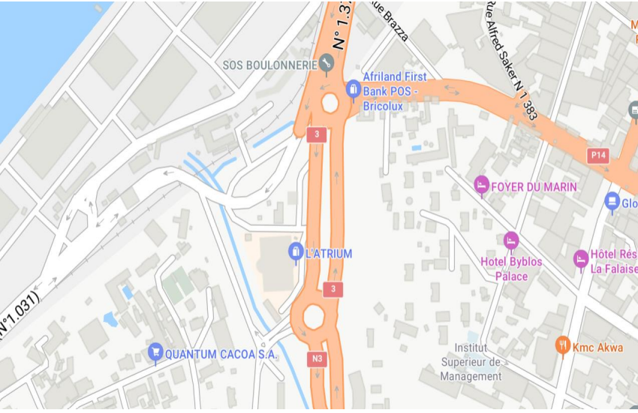
Figure 1 Google Map Location of SST

      - Evolution of SST
Over the years, thanks to the numerous contracts and projects successfully executed, particularly in the field of IT, the company has strived to position itself among the best in Cameroon in its various domains.
      - Mission of SST
Simple ideas, simple execution, and simple reports are the elements SST uses to achieve its objectives, which are:
- To instill in young people IT knowledge ranging from the most basic to the most advanced.
- To contribute to the promotion of web development in Cameroon and subsequently in Africa.
- To train IT professionals capable of adapting to and meeting the diverse demands of the job market, as well as working within a digital service company.
- To develop web platforms that meet the needs and expectations of clients as outlined in their specifications.

SECTION TWO: ORGANIZATIONAL STRUCTURE AND OPERATIONS OF THE COMPANY

2.1 Organizational Structure of the company
The organizational structure presents the set of tasks performed by each job position within the company.

1. General Management
At the head of the company is the General Manager, Mr. GAETAN DEMGHO. He is responsible for decision-making and defines strategies to ensure the company's sustainability and achieve its set objectives.

2. Administrative Management
This department is responsible for:
- Welcoming and receiving users and phone calls,
- Managing the General Manager’s agenda,
- Handling incoming and outgoing mail within the company,
- Overseeing the organization and overall smooth operation of the company.

3. Commercial Management
Its missions include:
- Supervising financial management procedures,
- Preparing a forecast budget,
- Presenting and monitoring budget execution,
- Managing online sales,
- Handling after-sales service,
- Drafting and analyzing financial reports (daily, monthly, semi-annual).

4. Technical Management
Its main responsibilities include:
- Repairing faulty equipment,
- Managing and leading projects,
- Procuring machines and work materials for the company,
- Overseeing stock management and maintenance.
This structure ensures an efficient distribution of responsibilities and contributes to the smooth operation of the company.

Figure 2: Organisational structure of SST
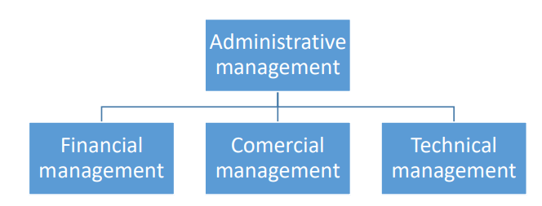

2.2 Presentation of SST’s activities and operations

2.2.1 Role of SST in the society
With the creation of any business, comes creation of entrepreneurship within the company and the society around the company. As such, with SST being a private company, its role to the society is the same as many other companies in Cameroon, which are as follows;
- Provides employment opportunities to citizens of the country
- Contributes to government revenue in the form of taxes the company has to pay.
- It increases domestic investment through competition and inflow of foreign capital.
It leads to the inflow of skills and development of highly demanded skills in the current, local and international market.

2.3 Available means SST
We will discuss on the internal and external environment of SST’s. The environment can be defined as the area in which the company operates, as well as all the parts related to it, and which can significantly influence its activities.

2.3.1 Internal environment and resources
- Organisational culture
Organisational culture is generally understood as all of a company’s beliefs, values and attitudes, and how these influence the behaviour of its employees. SST has a good belief of opening its doors to the public as from 8:00 AM, and have interns start their work as from 9:00 AM, with a maximum delay of 15 mins for late comers.
- Resources
The company has several resources. The following resources are those available within SST;
- Human resources
SST institutes is made up of highly qualified staff and professors
- Financial resources
The financial means of the company came from personal investment from its founders and creators.
- Material resources
SST institute is equipped with adequate equipment, adapted to the services it provides, which are accessible to all employees. These include
- An office
- Basic Office equipment and furniture
- Electrical current at all time with available outlets

2.3.2 External environment and resources
The company, as an economic and social entity, cannot operate in isolation. Therefore, it must place a strong emphasis on market evolution. In this logic, it surrounds itself with clients, suppliers, and partners and also has competitors.

a). COMPANY CLIENTS

Clients
These are individuals or organizations that receive services from SST in exchange for payment. Some of them include:
- Easylink
- ASCOMA
- BROLI
- GEPAC

Competitors
Competitors are all entities that offer services or products of the same nature, directly substitutable for those of SST. The SST company is in constant competition with many businesses, particularly in the field of ICT training. Some of these competitors include:

Company name | location | Field of activity
SECEL | Bonamoussadie | ICT
Klein technology | Nylon brazaville | ICT
GSC | Akwa | Technology
Table 1: List of Some Competitors of SST

SECTION TWO: CHRONOGRAM OF ACTIVITIES AND JUSTIFICATION

1.1 Chronogram of activities
This section of the chapter gives a detail explanation of the dates of weeks of the internship and activities carried out each week.
Week 1: From the 25TH of June to the 29st June
Arrival at SST office, and reception by the head of department, MS. KEMADJOU MAEVA, and later on by the owner of the company, M. DEMGHO GAETAN. Then I was introduced to other staff members and some of the interns for web and application development. Distribution and detailed explanation of the scheme of work for the internship, through Google Classroom and from other sources of the internet. Finally, initiation to work, and daily report of my progress to my professional supervisor.
Week 2 and Week 3: From the 1nd July to the 13th July
Introduction to computer maintenance and marketing strategies used in the field of business, this small course was thought by the marketing manager Ms. KEMADJOU MAEVA.
Computer maintenance was thought both theoretically and practically.
Week 4 and Week 5: From the 15th July to the 27th July
Introduction to modern front-end web development tools and programming languages, and installation of said tools onto my computer’s system. I was given notes and materials to improve my knowledge of HTML & CSS, & I was given daily practical tasks to do, evaluated the next day. Daily report was moved to weekly reports of my progress.
Week 6 and Week 7: From the 30th of July to 13th of August
Introduction to localhost server technology. Installation of WampServer on my computer.
Introduction to the PHP programming language, and an extensive guide to understand and master it as fast as possible. I was given notes progressively, practical examples and projects, daily task to be done digitally, and evaluated the next day. Then verbal weekly reports on the progress of my tasks.

Week 8 and Week 9: From the 14th of August to 26th of August:
We went out into the field to observe how IT equipment is purchased and delivered, how quotes and invoices are prepared, and we also took the time to undertake and develop a responsive no-code website (using WordPress) to enhance our design skills. The website was created for a security company called GAS Security.

Week 10: from the 28th to the 30th of August:
On the 30th, the internship certificates were handed out, and the end-of-internship evaluation forms were corrected. This marked the conclusion of our internship at SST’s premises. It was a very pleasant, warm, and enriching experience, especially in terms of developing my project.

1.2 JUSTIFICATION OF TOPIC
Having witnessed the struggles of unemployed individuals firsthand, I entered my internship at SST with a burning desire to bridge the gap between job seekers and potential employers.
My focus? Leading the development of an innovative job search platform, which not only helped address employment challenges but also enhanced my knowledge of business management and collaboration with others.

PART 2 : CONCEPTUAL FRAMEWORK

Part two of this internship report gives a detailed explanation of the frame of reference, a step-by-step process of building an education platform web app
- Chapter three (3) deals with the best building practices and benefits of implementing an e-commerce website to a company
- Chapter four (4) concerns the difficulties and insufficiencies during the period of internship, & my solutions to the problems.

CHAPTER THREE: DESIGN AND IMPLEMENTATION OF AN ONLINE EDUCATIONAL PLATFORM

CASE OF: SOCIETE DES SOLUTIONS TECHNOLOGIQUES

INTRODUCTION
An education platform is a digital system or online environment that provides access to learning resources, courses, and tools to facilitate teaching and learning. It enables students, teachers, and institutions to interact, share knowledge, and track progress efficiently.

Definition of terms
- Definition of the main terms
- Full stack development is the construction of a website both on the client side(front-end) and server side (back-end)..
- Front-end web development
- Front-end development is the development of the graphical user interface of a website, through the use of HTML, CSS and JavaScript
- HTML: HTML is the standard mark-up language for creating web pages. It describes the structure of a web page and it consists of a series of elements.
- CSS: CSS is a stylesheet language used for describing the presentation of a document written in a mark-up language such as HTML.
- JavaScript: JavaScript is a scripting language that enables you to create dynamically updating content, control multimedia and animate images.
- Back-end development
Back-end development refers to server-side development. It focuses on databases, scripting, website architecture. It contains the behind-the-scene activities that occur when performing any action on a website.
- Definition of other related terms
- Internet:
The internet is a worldwide computer network that transmits a variety of data and media across interconnected devices.
- Website:
A website set of related web pages located under a single domain name typically produced by a single person or organization
- RWD:
An RWD is the approach which suggests that design and development should respond to the user’s behavior and environment based on the screen size, platform and orientation.
- Web browser:
A web browser is a software application used to access information on the Web
- Plug-in:
A plug-in, also called add-on or extension, is a computer software that adds new functions to a host program without altering that host program itself.
- Website architecture:
Website Architecture is the planning and design of the technical, functional and visual components of a website – before it is designed, developed and deployed.
- Text Editor:
A text editor is a simple computer program that allows users to create, change, or edit plain text files.
- Database:
A database is an organized collection of structured information, or data, typically stored electronically in a computer system. A database is usually controlled by a DBMS. MySQL was used as the DBMS for this project.

- Script and scripting:
- A script or a computer-script is a list of commands that are embedded in a web-page normally and are interpreted and executed by a certain program or scripting agent.
- Web scripting is the process of creating and embedding scripts in a web page.
- Web application
It can be defined as an interactive application built using web development technologies that users can access from their browser.
- Programming language
This refers to a set of instructions written by a programmer to deliver instructions to the computer to perform a specific task. Some examples are: C, C++, Python and Java.
- Unified Modeling Language

It is a standardized general-purpose visual modeling language used for specifying, visualizing, constructing and documenting a software system.
- Framework
A collection of code components that provide a ready made foundation for building applications.
- ORM(Object Relational Mapper)
A programming tool that bridges the gap between relational databases and object-oriented programming languages. It allows you to interact with databases using objects, simplifying data access.

- OOP(Object-Oriented Programming)
A programming paradigm that revolves around objects. Objects encapsulate data (attributes) and related operations (methods) that act on that data. OOP principles like inheritance, polymorphism, and encapsulation promote code reusability, maintainability, and modularity.

BENEFITS

Web apps have many different uses, and with those uses, come many potential benefits. Some common benefits a web app include:
- Faster support
Obviously, chat is easy to reach for customers. It takes less time to resolve a customer’s issue using a chat app.
- Always up-to-date
Web apps do not require to be updated often, in the way common apps usually do. It is the website/URL to which the application is directly linked that gets updated to this most recent version. And, as everyone accesses the same version of the web application via the same URL, all users use the most up-to-date same version of it all times.
- Free from downloading needs
Since by using a web browser, a user can directly interact with the app, it does not have to be installed or downloaded separately from different platforms like Google Play Store or Apple’s App store.
- Runs easy
Web design services for a default web app are programmed such that they can run on any operating system. As long as the web browser is in place, their interface with various screen sizes allows them to easily adapt to iOS, Android or Windows, among many others.
- Less drama
Chat agents experience less emotional exhaustion after difficult service interactions. It’s easier to distance yourself from a mean text than a shouting customer who complains.
- Consumer engagement
For any business to connect with the global market, it is essential to communicate the information you want with the audience. The web app servers act as a platform to showcase your products/services.
- Expansion
Online data have to be updated frequently to follow trends and business improvements. For an e-commerce app for example, the app should have stocks and new products to be updated regularly. Web apps make the task simple by letting developers add just the updated new content in the servers instead of making changes in the entire source file.
- Customer issues
Chat agents have time to focus on complex issues and personal customer interactions, thereby ameliorating the quality of services offered.
- No waiting queues
Customers do not have to stand on a queue in order to collect information when necessary. Research by Software Advice shows that the extinction of waiting queues is the primary reason why people prefer chat apps.

1.3: FACTORS AFFECTING A WEB APPLICATION DEVELOPMENT

1. Ease of Use
A web application should be simple and quick to set up. If an app asks too many questions or requires complex configurations before use, users may lose interest. People prefer apps that help them complete tasks with minimal effort.

2. Design and Features Selection
The time and cost of developing a web app depend on its design complexity and the extra features it includes. However, these aspects should always align with the specific needs of the business to ensure the app is both functional and visually appealing.

3. Performance and Speed
A good web app should be fast and efficient. Users prefer a smooth experience with a clean and simple interface. Slow apps or those filled with unnecessary ads and pop-ups can frustrate users and make them stop using the app.

4. Compatibility Across Platforms
An app should work well on different devices and browsers. If an app functions properly on one platform but fails on another, users may feel restricted and discouraged from using it. Ensuring compatibility across multiple platforms makes the app more accessible and user-friendly.

5. Use of Reliable Technologies
Choosing high-quality and well-established technologies helps improve the app’s overall functionality and user experience. Technologies like PHP and Python allow users to interact smoothly with the app and enhance performance.

6. Visibility and Online Presence
Launching a web app is just the beginning; continuous effort is needed to make it visible to users. Search Engine Optimization (SEO) and online marketing strategies help increase the app’s reach and attract more users over time.

1.4: PROCESS OF AN E-LEARNING WEBSITE

1.4.1. DEVELOPMENT TECHNOLOGIES

Programming Languages
- PHP
PHP is a server-side programming language mainly designed for the development of web applications. It is easy and simple to learn, and easily connects to database. Its logo is shown below.

- JavaScript
JavaScript is a scripting language. This language is executed on the client side and it fits into the HTML code of a web page. It is easy to learn and increases the interaction of a website. Its logo is shown below.

Structuring

- HTML5
HTML is the standard markup language for documents designed to be displayed in a web browser. HTML is easy to learn and use, it is supported by all browsers and is free. Its logo is shown below.



- CSS
It is a computer language that describes the presentation of HTML documents. Its logo is shown below.


Server
- WampServer creates a local web server environment serving web pages on localhost. Its logo is shown below.


Code editor
- Visual Studio Code
The code editor used was Visual Studio Code, commonly referred to as VS Code. It is a source-code editor made by Microsoft for Windows, Linux and macOS. Its features include support for building and debugging modern web and cloud apps. Its logo is shown below.



Web Browser
- Google Chrome
A popular web browser developed by Google. It's known for its speed, security, and extensive library of extensions.
Frameworks
- Bootstrap v5.0
It is the newest version of Bootstrap, which is the most popular HTML, CSS and JavaScript framework for creating responsive websites. It has been used to insert font-awesome in the CSS file. Its logo is shown below.


Object Modelling Tool
- Start UML

1.4.2. MODELING

The modeling language used to design the system is the UML. UML is a way to visually represent the architecture, design and the implementation of complex software systems.
UML diagrams
There are various types of UML diagrams but we are going to focus just on three of them which are: the use case diagram, class diagram and sequence diagram. of its ease of use.

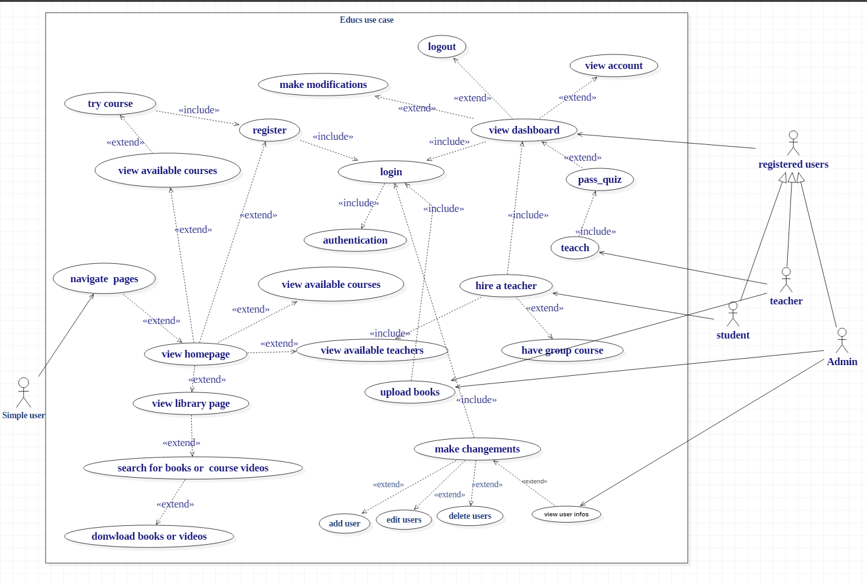
  - Use case diagram
Figure 3: use case diagram

  - class diagram

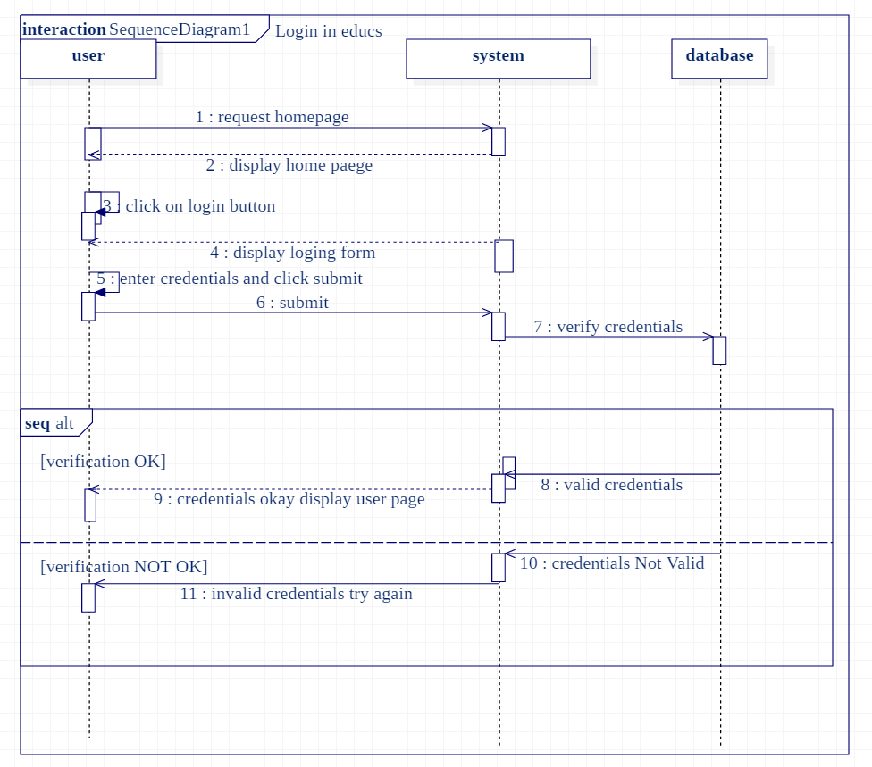
  - sequence diagram (login into account):
figure 5: sequence diagram (login into educs account)

1.4.3. DEVELOPMENT ARCHITECTURE

In other to realize an E-learning web app, I made used of the MVC architecture. The MVC architecture is a solution for developing applications permitting a great flexibility in the realization between the enterprise, their clients and its suppliers
In such an architecture, we have separated the application or processing in to 3 parts. We therefore obtain the following:
♣ Model
♣ View
♣ Controller
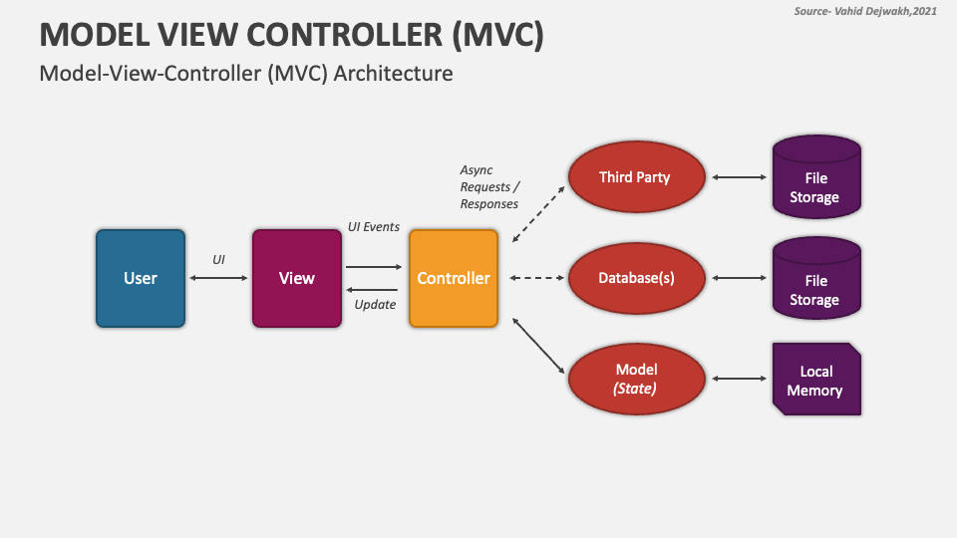
Figure 6 : Presentation of the MVC architecture
Each of these three layers plays an important role in the creation of the application
• The Model: This component represents the data and the business logic of the application.
• The view: The view code is made up of all functions that directly interact with the user (It is the code that your app look nice and other wise defines how your user sees and interact with
• The Controller: The controller accept input and converts it to command for the model or view

1.4.4 IMPLEMENTATION

The implementation of an E-learning platform is as follows;
- The user accesses the application via a browser where he/she will first of all view a website (Home page).
- The user can browse the web application to know more the different web pages of the app (by clicking on an option on the navigation bar of the Home page):
- On the ABOUT section, the user is able to make a registration of his choice (teacher or student)
- HOME: To stay in the home page
- ABOUT: To know more about application
- LIBRARY: to get to educs library where you can download books
- LOGIN: To log into his account.
- Get_ started: this is to register as a teacher
- Start now: to register as a student

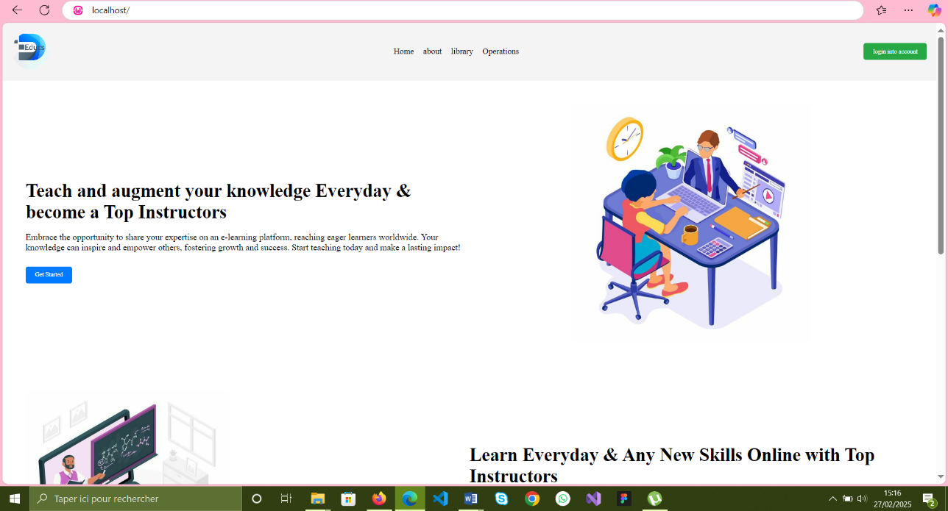
Figure 7: home pages

- Teacher registration page
In this E-learning app, when we click on the get started button found on the home page about section, there is a registration form that is displayed on the screen where we have to sign up with personal details like name, Email Address, date of birth, address, telephone number that will serve in the continuity of account creation.
It can be noted that:
- All the fields have been defined with a NOT NULL constraint except for the last name field, meaning that all of them must contain a value: an error message will be displayed if the user fails to enter values for these fields.
- Also, a valid email address and date of birth have to be entered.
After all the information have been entered, we can now click on the button entitled “register” in order to move to the next page.
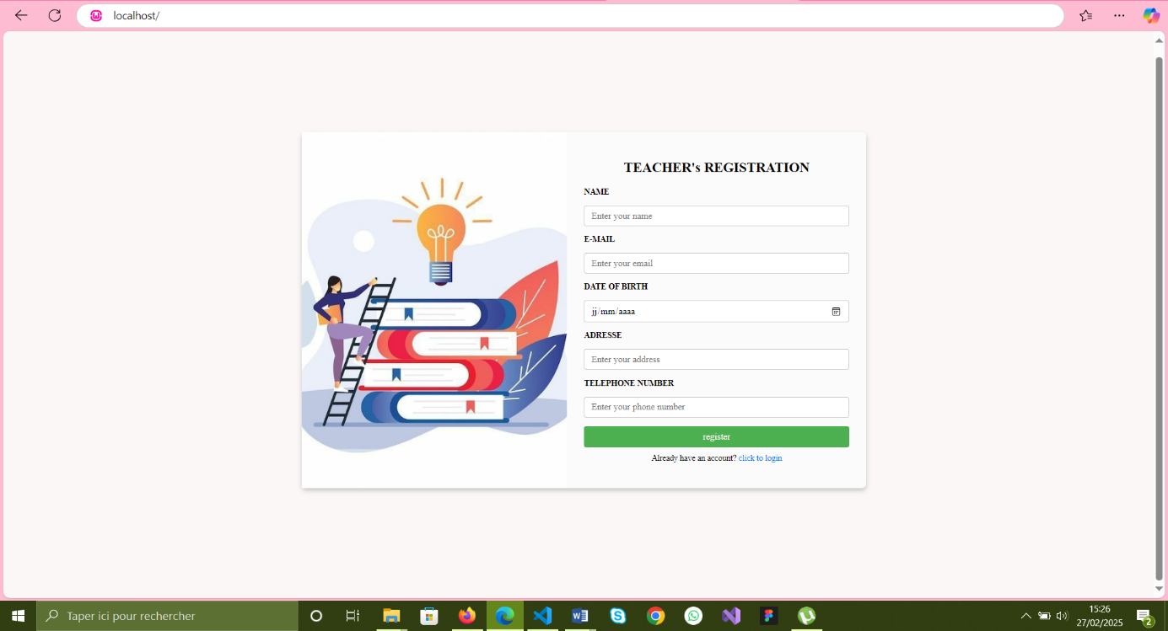
Figure 8: teacher registration page

- Quiz page

- This page is main for users who wants to become teachers.

- The age is calculated from the DOB and if the user is 18 years and above, he/she is eligible to register and redirected to the quiz page where he will have to answer to a certain quiz to test his competence based on the field of study he/she wants to teach on our application.
The quiz page has only one button on his bar

- Back to home: redirects you to home page

How to start the quiz?

To start a quiz, you have to enter the name of the course you want to teach example: English, programming, science etc.
After that click on the start quiz button, the page will ask you to authorize camera on to continue and leaves a certain time for the supervisor (behind his own computer) to make a place checkup after then the question of the quiz will be generated.

When to submit quiz
When the user is done answering the quiz, he clicks on the submit button and based on his result, he may be redirected or nor to the next pages. If at the he/she finishes the quiz before time, he can check back his answer before submitting. But if time finishes before he had answered all the questions, the quiz is automatically submitted.

Quiz timer is based on;
The course type
Number of questions
Number of peoples who succeeded the quiz.

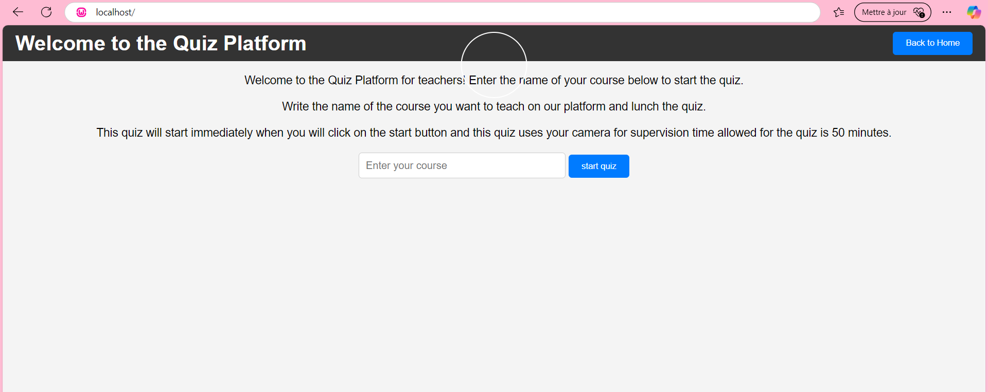

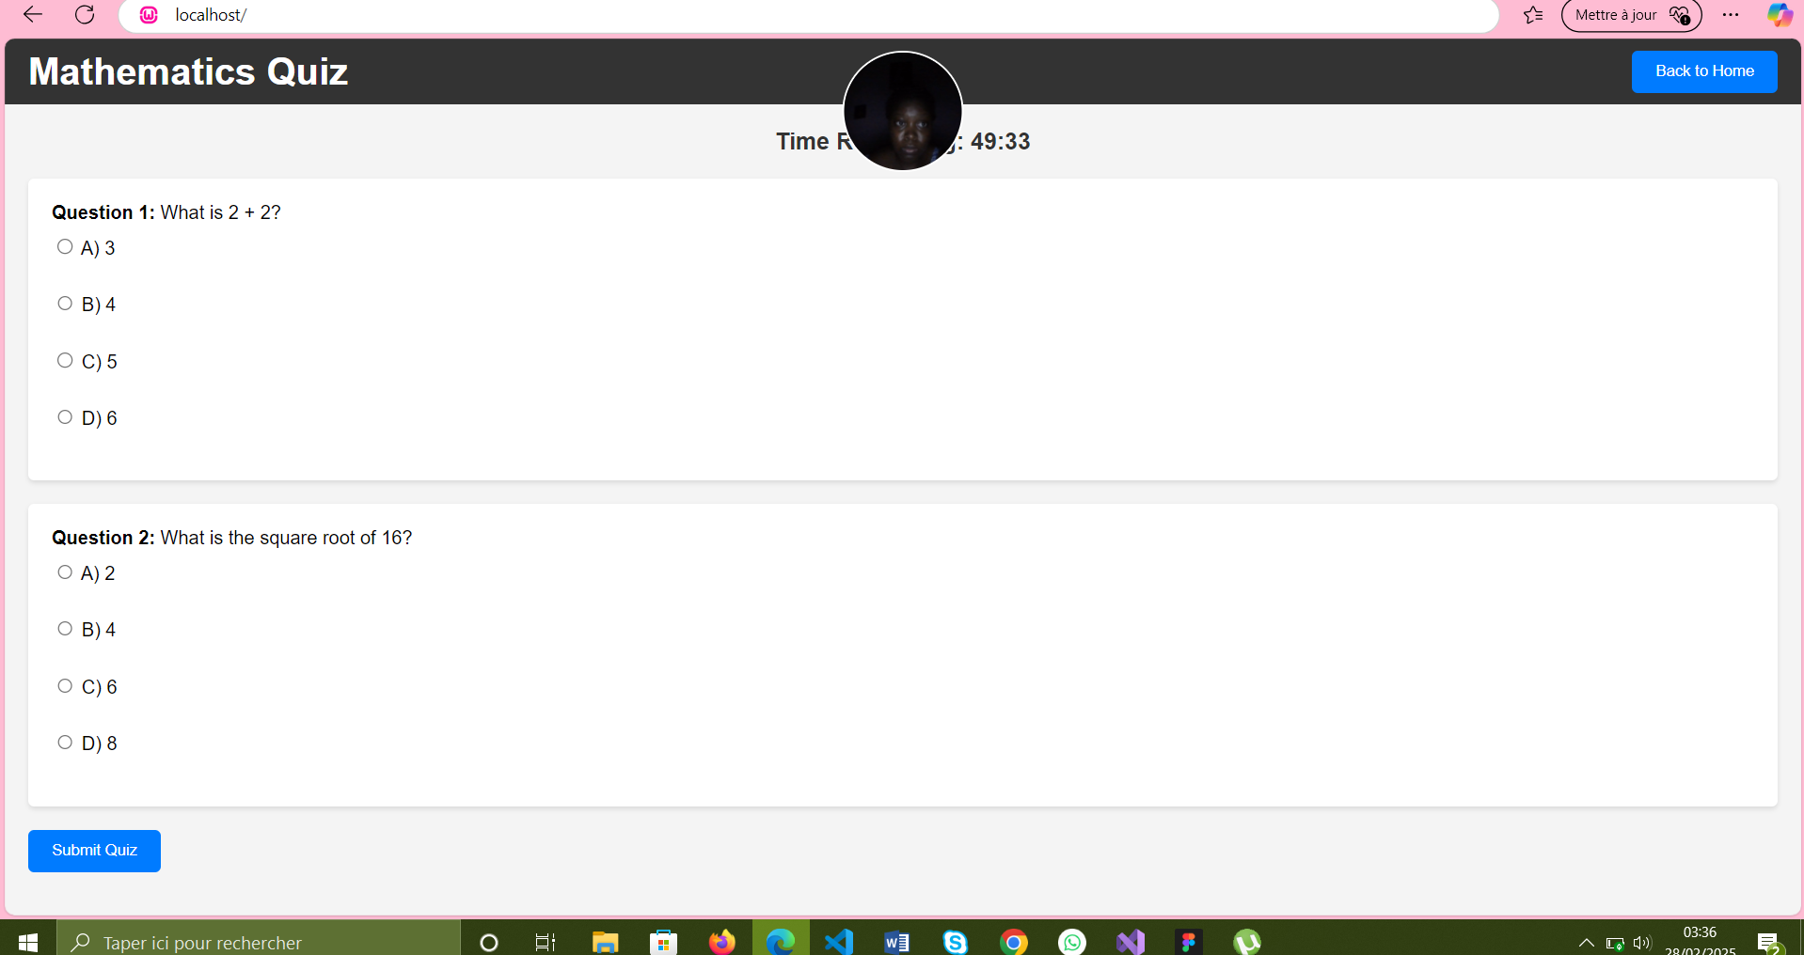

Figure 9&10: quiz page

- Student registration page
In this E-learning app, when we click on the start now button found on the home page about section, there is a registration form that is displayed on the screen where users who wants to register as students in the application must filled with personal details like name, Email Address, telephone number that will serve in the continuity of account creation.
It can be noted that:
- All the fields have been defined with a NOT NULL constraint, meaning that all of them must contain a value: an error message will be displayed if the user fails to enter values for these fields.
- Also, a valid email address have to be entered.
After all the information have been entered, we can now click on the button entitled “register” in order to move to the next page.


figure 11: student registration form

CHAPTER 4: INSUFFICIENCIES AND RECOMMENDATIONS

INTRODUCTION
In this chapter, we will discuss on the challenges faced by employees and interns of SST, faced by me during the implentation and suggestions to remedy to them. This chapter is divided into two sections.
Section 1 (one) brings out the difficulties and insufficiencies which highly influenced SST’s interns and registered candidates
In section 2 (two), we shall discuss about the suggestions and recommendations which might considerably solve the problems encountered.

SECTION ONE : DIFFICULTIES AND INSUFFICIENCIES

Difficulties
As far as achieving more knowledge, a lot of difficulties were faced at the start and during the internship, especially during the identification of documents, reading such documents and to use relevant materials when it was necessary. As such, the difficulties faced during internship and insufficiencies faced by interns will be discussed below.
- The supervisors being already familiar with the technologies and technics in the field of computer technology assumed we were taught in school or had knowledge on some of the technologies such as PHP, OOP and mobile applications, and forgot we are new in the field pf computer engineering. This made progress during the internship difficult for interns in the HND education program.
- The complete absence of working Wi-Fi connection in the buildings of SST forced all individuals to pay and use their own internet connection for research or to fulfil tasks.
- The location of the building in which the internship was carried out was not ideal. The internet connection of some ISP such as Orange Cameroon and NEXTTEL was either slow or unavailable. This caused employees and interns to rely other service providers, furthermore increasing cost and time wasted.
- During implementation, I have difficulties to implement all the educs functionalities
- Late acquisition of an academic mentor which consequently reduce my implementation time since by the beginning I was just working alone and at his arrival we were to make much changes

Insufficiencies
- Language barrier: SST is a French speaking entity with very few members who can understand, let alone speak English. Almost all of SST employees I met were unable to translate and communicate information from French to English to the interns in the English education system. Pairing that with my inability to translate some words from English to French caused some misunderstandings with my professional supervisor.
- Adapting to the working environment: Due to the sudden change in the environment and unfamiliarity of the professional world, it took some time to get used and cope with the working environment. Therefore, in the first days of the internship we did not have much work to do. Thus was a challenge since we remain idle and bored for the first week
- Limiting self-belief: The start of the internship was overwhelming to say the least. This caused a natural reaction to set a limiter to our self-belief. This led to slow performance with little to no yield in quality.
- Financial resource: I personally had a lack of financial resources to buy the appropriate APIs which were to be used in the application functionalities

SECTION TWO: SUGGESTIONS AND RECOMMENDATION

Based on the difficulties and insufficiencies mentioned above, the following suggestions and recommendations respectively are advised for all parties to follow.

2.1 Suggestions
- For supervisors not to assume the competence level of an intern, they should give a proper test to all interns at the start of the internship. This should give the supervisors a proper image on each intern’s level of proficiency in their respective fields.
- We now live in a world where a big chunk of business activities is done online. As a result, SST needs to provide adequate and reliable data connection to facilitate research and work for the benefit of the company, be it through Wi-Fi or optic fibres connection.
- SST needs to purchase the essential office materials mentioned earlier. As a company in the field of computing, they should be equipped with the minimum.

2.2 Recommendations
- Since Cameroon is a bilingual country, SST should make sure most of their employees are able and willing to express themselves in both English and French, & for interns to revise on the language they face the most difficulties before going for an internship, in order to facilitate communication.

GENERAL CONCLUSION

In regard to our internship at SST which was very significant and skill full, both professionally and academically. We were tasked to building websites and application similar to the ones giving to us and showed how to host them locally.
Our internship at SST allowed us to appreciate the realities of professional life, thanks to this experience, we were able to assimilate the different domains of computing. On the other hand, we now know how to build a website and web application from scratch (purely through code).
During this mission, we had the opportunity to meet the employees of SST, interns of the other departments of the company, and network with most of the individuals associated with the company.

Appendix:

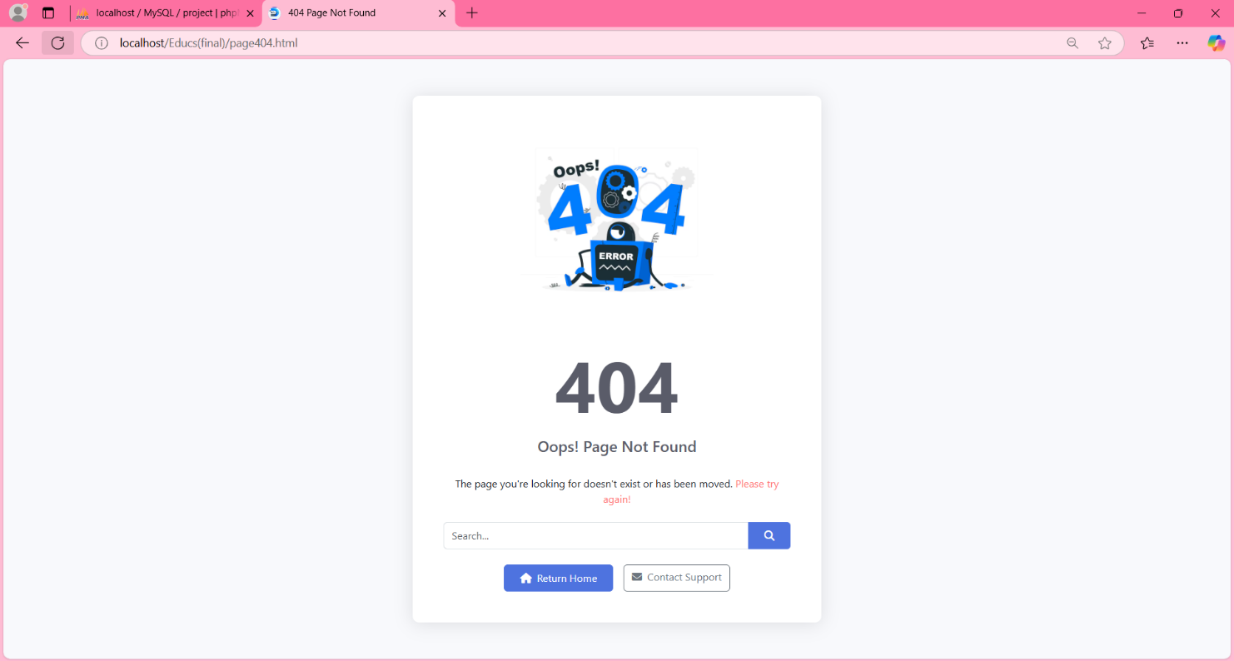
The above page is displayed when a user tries to have access to a resource he doesn’t have right to.

WEBOGRAPHY

- Implementation of an e-learning web app: https://chat.deepseek.com/a/chat
- Design of website: https://chat.deepseek.com/a/chat
- Definition of web app: https://chat.deepseek.com/a/chat
- Benefits of web app: https://chat.deepseek.com/a/chat
- Advantages and disadvantages of web app: https://chat.deepseek.com/a/chat
- Factors affecting web app development: https://chat.deepseek.com/a/chat
- Factors affecting web app development: https://chat.deepseek.com/a/chat

